Measurement Protocol PAX

General Information:

Test date: 06/11/26 | Date prev. test: 13/08/20 | Test number: 2
Tested by: Jay Frothingham | PAX number: PB-043 | Installed at ant.:
Comments:
Replaced X-pam from 009, remeasurement.
Known problems:

Setup:

Power supply: | OK NOK | Communication: | OK NOK
Supply current +6V: 1.084A |  | ssh obs@antcntl
Supply current -6V: 0.109A |  | ssh ataant@paxtester | pw: q@n@t
Supply current +5V: 0.045A |  | telnet pax | “help”
 |  | CTRL + ] | “close”

RF Test with VNA:

VNA Setup:

Load configuration: Passband_PAX.csa
Freq Start: 1.0 GHz | Freq Stop: 13.0 GHz | Power Level: -20 dBm
Averaging: enabled | Averaging count: 15 | N. Points: 801
VNA : Agilent N5230C 10MHz - 20GHz

VNA to PAX connection: | 1m ABC-CA18 Cable + 20dB Attenuator
Input Power Level to PAX:  (Measured) | @1GHz:  -40.2dBm | @4GHz:  -40.7dBm | @8GHz:  -41.2dBm | @12GHz:  -41.4dBm

PAX to VNA connection: | 2m Fibre Cable + Fibre Diode + AOX Amplifier + 1m ABC-CA18 Cable

Measured Passband with Attenuator set to 7dB each (Complete Link):

X
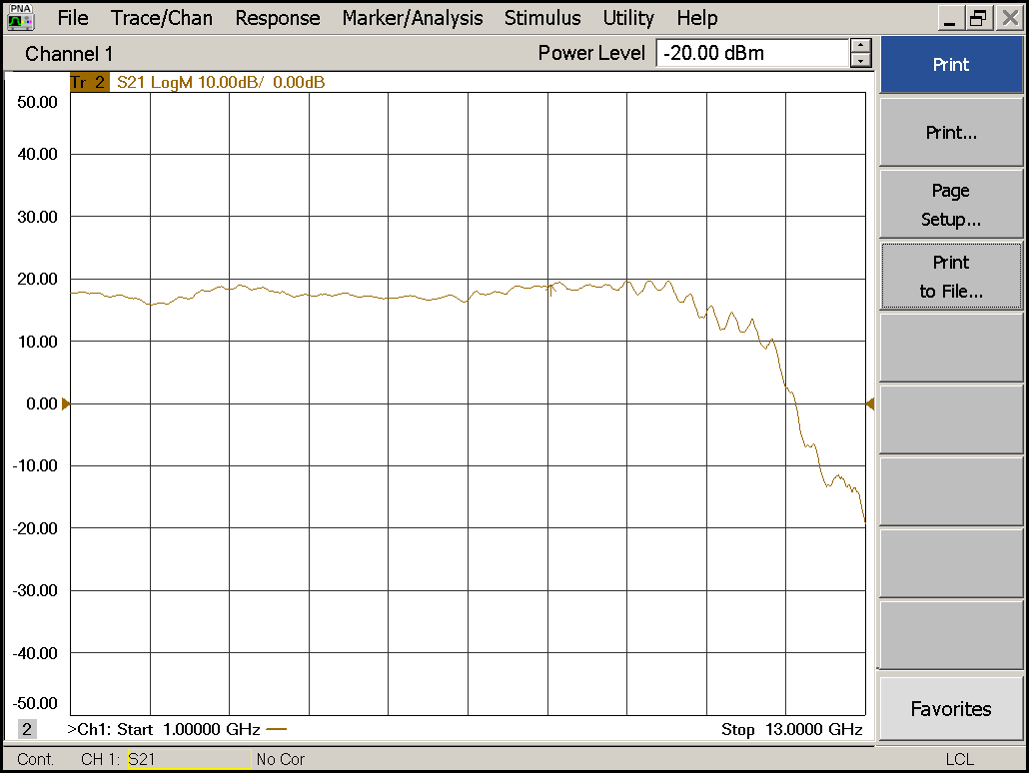
Flatness: | OK NOK | Unwanted Features: | Yes No

Y
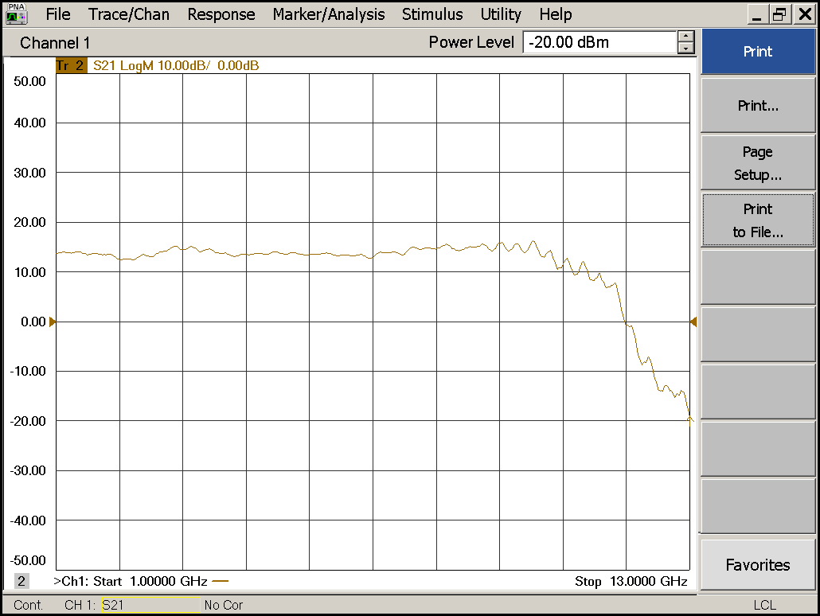
Flatness: | OK NOK | Unwanted Features: | Yes No

Power Sweep (Complete Link):

Load configuration: Power_Sweep_PAX.csa
Power Start: -40dBm | Power Stop: -20dBm | Frequency : 4.0GHz
PAM Attenuator: 0dB |  | N. Points: 801

X
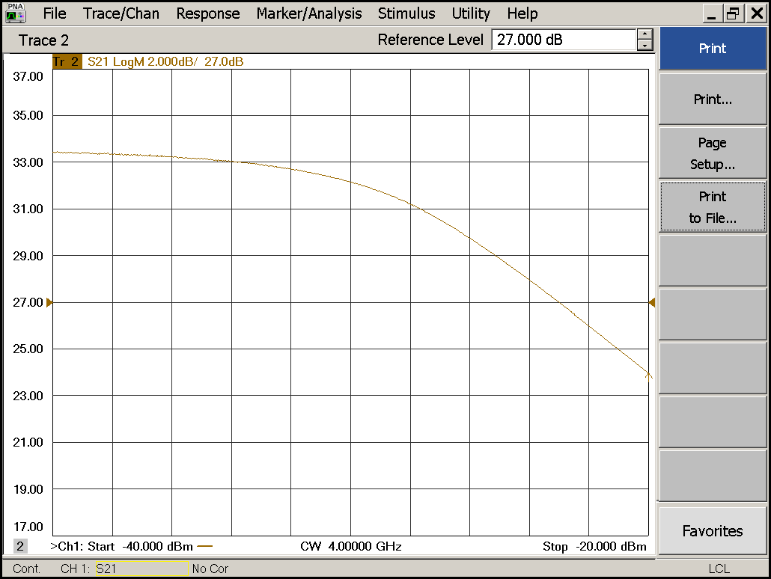
Compression point: | OK NOK | Unwanted Features: | Yes No

Y
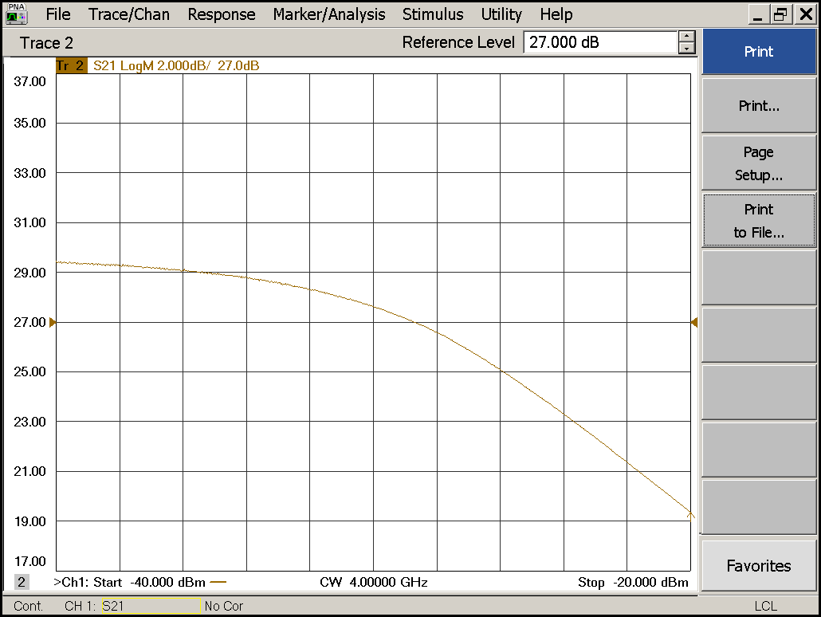
Compression point: | OK NOK | Unwanted Features: | Yes No
Detector Calibration and Attenuator Sweep Pol X:

Load configuration: Detector_Calibration_PAX.csa
Freq : 4.0 GHz | Power Level: -20dBm | Sweep Time: -20sec
Sweep Mode: CW | Power Level at PAX Input (Measured): -40.6dBm

X
CW Input Power [dBm]: | Attenuator Value A [dB]: | Attenuator Value: B [dB]: | Detector  Value: | Power Meter  Value [dBm]:
-40.6 | 0 | 0 | - | 12.9
-40.6 | 0 | 3 | - | 12.9
-40.6 | 0 | 6 | - | 12.3
-40.6 | 0 | 9 | - | 10.3
-40.6 | 0 | 12 | - | 7.4
-40.6 | 0 | 15 | 0.8484 | 4.7
-40.6 | 0 | 18 | 0.5139 | 1.4
-40.6 | 0 | 21 | 0.2868 | -1.7
-40.6 | 3 | 21 | 0.1421 | -5.1
-40.6 | 6 | 21 | 0.0745 | -8.1
-40.6 | 9 | 21 | 0.0385 | -11.2
-40.6 | 12 | 21 | 0.0201 | -14.2
-40.6 | 15 | 21 | 0.0107 | -17.1
-40.6 | 18 | 21 | 0.0056 | -20.4
-40.6 | 21 | 21 | 0.0033 | -23.5
-40.6 | 24 | 21 | 0.0022 | -26.4
-40.6 | 27 | 21 | 0.0016 | -29.5
-40.6 | 30 | 21 | 0.0014 | -32.7
-40.6 | 30 | 24 | 0.0012 | -35.4
-40.6 | 30 | 27 | 0.0012 | -37.87
-40.6 | 30 | 30 | 0.0012 | -40.2

Use Noise Source: Atlantic AS6333
Freq : 1.0 - 12.0GHz | Power Level: -41.8dBm
DC Supply: 28V

X
Input Power [dBm]: | Attenuator Value A [dB]: | Attenuator Value: B [dB]: | Detector  Value: | Power Meter  Value [dBm]:
-41.8 | 0 | 0 | - | 11.5
-41.8 | 0 | 3 | - | 10.6
-41.8 | 0 | 6 | - | 9.2
-41.8 | 0 | 9 | - | 7.2
-41.8 | 0 | 12 | - | 4.7
-41.8 | 0 | 15 | 0.8241 | 2.2
-41.8 | 0 | 18 | 0.4526 | -1.0
-41.8 | 0 | 21 | 0.2494 | -3.9
-41.8 | 3 | 21 | 0.1289 | -6.9
-41.8 | 6 | 21 | 0.0642 | -10.0
-41.8 | 9 | 21 | 0.0332 | -12.9
-41.8 | 12 | 21 | 0.0168 | -15.9
-41.8 | 15 | 21 | 0.0095 | -18.6
-41.8 | 18 | 21 | 0.0050 | -21.9
-41.8 | 21 | 21 | 0.0030 | -25.0
-41.8 | 24 | 21 | 0.0021 | -28.0
-41.8 | 27 | 21 | 0.0016 | -30.7
-41.8 | 30 | 21 | 0.0013 | -33.9
-41.8 | 30 | 24 | 0.0013 | -36.5
-41.8 | 30 | 27 | 0.0011 | -38.7
-41.8 | 30 | 30 | 0.0011 | -40.8

Detector Calibration and Attenuator Sweep Pol Y:

Load configuration: Detector_Calibration_PAX.csa
Freq : 4.0 GHz | Power Level: -20dBm | Sweep Time: -20sec
Sweep Mode: CW | Power Level at PAX Input (Measured): -40.6dBm

Y
CW Input Power [dBm]: | Attenuator Value A [dB]: | Attenuator Value: B [dB]: | Detector  Value: | Power Meter  Value [dBm]:
-40.6 | 0 | 0 | - | 13.1
-40.6 | 0 | 3 | - | 13.1
-40.6 | 0 | 6 | - | 12.4
-40.6 | 0 | 9 | - | 10.3
-40.6 | 0 | 12 | 0.8471 | 7.4
-40.6 | 0 | 15 | 0.7982 | 4.5
-40.6 | 0 | 18 | 0.4339 | 1.2
-40.6 | 0 | 21 | 0.2342 | -1.9
-40.6 | 3 | 21 | 0.1141 | -5.3
-40.6 | 6 | 21 | 0.0595 | -8.2
-40.6 | 9 | 21 | 0.0305 | -11.3
-40.6 | 12 | 21 | 0.016 | -14.3
-40.6 | 15 | 21 | 0.0087 | -17.3
-40.6 | 18 | 21 | 0.0046 | -20.6
-40.6 | 21 | 21 | 0.0029 | -23.7
-40.6 | 24 | 21 | 0.002 | -26.7
-40.6 | 27 | 21 | 0.0015 | -29.8
-40.6 | 30 | 21 | 0.0014 | -33.0
-40.6 | 30 | 24 | 0.0013 | -35.7
-40.6 | 30 | 27 | 0.0013 | -48.2
-40.6 | 30 | 30 | 0.0012 | -40.5

Use Noise Source: Atlantic AS6333
Freq : 1.0 - 12.0GHz | Power Level: -41.8dBm
DC Supply: 28V

Y
Input Power [dBm]: | Attenuator Value A [dB]: | Attenuator Value: B [dB]: | Detector  Value: | Power Meter  Value [dBm]:
-41.8 | 0 | 0 | - | 11.8
-41.8 | 0 | 3 | - | 11.0
-41.8 | 0 | 6 | - | 9.6
-41.8 | 0 | 9 | - | 7.8
-41.8 | 0 | 12 | 0.8471 | 5.3
-41.8 | 0 | 15 | 0.752 | 2.8
-41.8 | 0 | 18 | 0.4066 | -0.3
-41.8 | 0 | 21 | 0.2190 | -3.2
-41.8 | 3 | 21 | 0.1111 | -6.2
-41.8 | 6 | 21 | 0.0548 | -9.3
-41.8 | 9 | 21 | 0.0281 | -12.2
-41.8 | 12 | 21 | 0.0142 | -15.3
-41.8 | 15 | 21 | 0.008 | -18.0
-41.8 | 18 | 21 | 0.0043 | -21.4
-41.8 | 21 | 21 | 0.0028 | -24.5
-41.8 | 24 | 21 | 0.0020 | -27.6
-41.8 | 27 | 21 | 0.0016 | -30.4
-41.8 | 30 | 21 | 0.0014 | -33.8
-41.8 | 30 | 24 | 0.0013 | -36.3
-41.8 | 30 | 27 | 0.0012 | -38.5
-41.8 | 30 | 30 | 0.0013 | -40.5

Inspection:

Visual:
Fibre Connectors Clean | Comments: | OK NOK
Fibre Connector Mechanical | Comments: | OK NOK
RF Cable | Comments: | OK NOK
RF Connectors Clean | Comments: | OK NOK

Functions:
Read Temperature Value | Comments: | OK NOK
LNA Settings | Comments: | OK NOK
Temperature Stabilisation | Comments: | OK NOK
 |  | OK NOK

